# **Culvert Model v.2.1 Guide**

*This reference is for the updated 2.1 version of the Cornell Culvert Model (updated July 2019). The directory structure is the same as version 2.0.*

*The major change in this version of the model is how peak flow is calculated from the 24-hour runoff event. Rather than using the graphical method outlined in TR-55 to convert daily flow into instantaneous flow, we have relied on regression relationships developed from 28 USGS-gauged watersheds from within and around the Hudson River watershed region of NY State, which significantly reduces the amount of peak flow expected, particularly in small watersheds less than 2 square miles.*

***Important note:*** *the tools are currently set up to default to the UTM 18N projection. If this is not the correct projection for your region, you will have to adjust the output extent of the culvert tools.*

1. Set up your file structure

* The File structure diagram is in A.1 of this document. Your files must be organized in this precise way because the python scripts assume this structure to find your input files. Make sure your data files (i.e. field data and precipitation normal for the region) contain the same name as the project folder.
  + Save your NAACC field data in a csv file with the same name as your project directory (e.g. **ALB/ALB.csv**).
  + Make a copy of the GIS_files folder and save it in your working directory (e.g. ALB/GIS_files)
  + Save a copy of the CulvertModelFiles folder in the same location as your working directory.

1. Export Data

* Right-click on the extract_NAACC.py file in the “CulvertModelFiles” folder. Chose “Edit with IDLE”
* Press F5 to run the program. The first prompt “Enter the name of your data folder:” type in the name of your project folder (e.g. ALB)
* For the second prompt, input ‘y’ if the columns are in the specified columns in Appendix 2 (the same as the file NAACC_sample.csv). It does not matter the exact column name.
  + Type ‘n’ if instead of these column placements, your data simply has the **exact** column names noted in Appendix 2.
* Upon successful completion of the program, you should now have two new files in your project folder called (e.g.) ALB_field_data.csv, and ALB_not_extracted.csv

1. Create new shapefiles in **ArcCatalog**

* 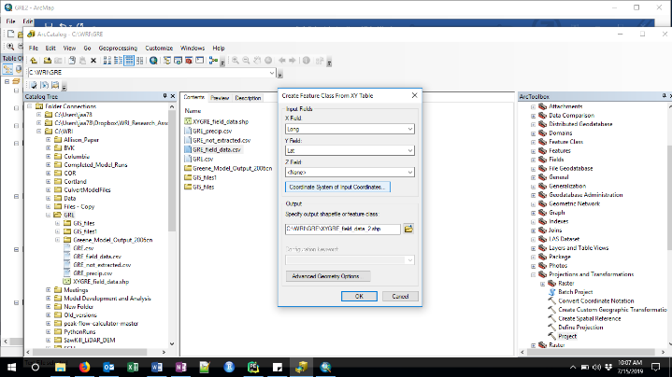Create a new point shapefile in **ArcCatalog** from the extracted culvert file, project it to UTM coordinates (call it **XY_utm)**.
  1. Right click on your _field_data.csv file, and select “Create Feature Class” 🡪 “From XY table”. This will read in the correct columns from the field data file, but you need to define the coordinate system of the Lat/Lon points. Click on the “Coordinate System of your points” icon. Then chose *Geographic Coordinate Systems 🡪 World 🡪 WGS* 1984. Save this file in your project folder, it doesn’t matter what you call it because it’s an intermediate file.
  2. Open the Project tool in **ArcCatalog** and select the pointfile you just created to project to a new pointfile, called **XY_utm** (Keeping this precise name is useful because the Arc Culvert Tools assumes this name for the crossing point file). Chose Projected Coordinate Systems 🡪 UTM 🡪 NAD83 🡪 NAD 1983 UTM Zone 18.

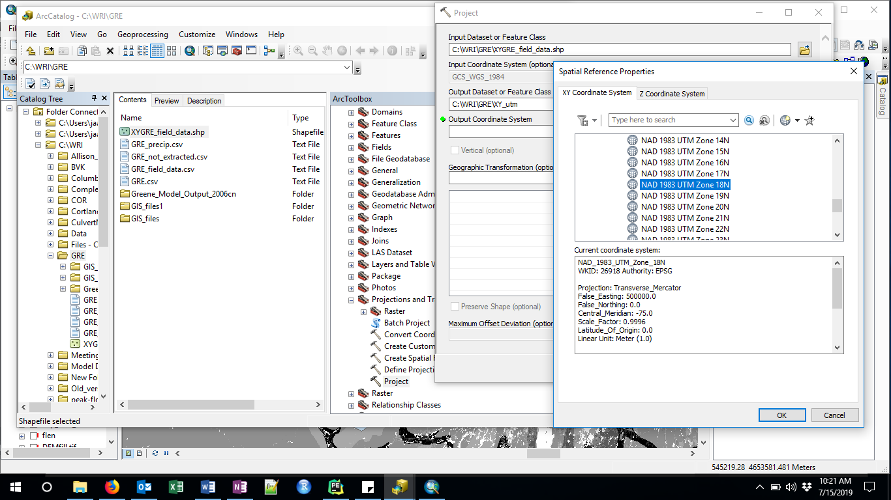

* Create a new (empty) polygon shapefile that you call **clip.shp** in the GIS_files folder, set it to the projected coordinate system NAD 1983 UTM Zone 18

1. Create a new ArcMap document in your working directory, and load all the input data files:

* Detailed instructions for obtaining these data files are in the Cornell_Model_Data file. These files include:
  1. A DEM file from which watershed boundaries will be estimated.
  2. NHD line shapefile of streams
  3. Curve number raster file
  4. [OPTIONAL] The StreamStats regional NY region file (Allows for estimation of Area-based streamstats flow statistics for comparison to model output). If using NRCC data, don’t use this.
  5. Precipitation data (Chose one of two options – must have one)
     1. [OPTIONAL] NOAA precipitation raster files
     2. [OPTIONAL] A csv file of average precipitation statistics for your county from NRCC, named using the naming convention ALB_precip.csv and saved in your project folder (so this will NOT be loaded into ArcMap at this time, it will be needed in the next Python run).
  6. The shapefiles you created using ArcCatalog in Step 3:
     1. A point file created from your field_data.csv file that shows where your road-stream crossings occur
     2. A clip polygon shapefile
  7. In ArcMap, create a new polygon in the clip shapefile that encompasses a large enough area to contain all contributing areas flowing to your stream crossing points. Use the NHD flowlines to determine that area by looking to make sure that any stream on which there is a culvert point downstream is fully included within the clip area, and allow the clip polygon to extend at least as far as the headwaters of unconnected streams in order to ensure you will not be cutting-off any watersheds (See figure 1, below).

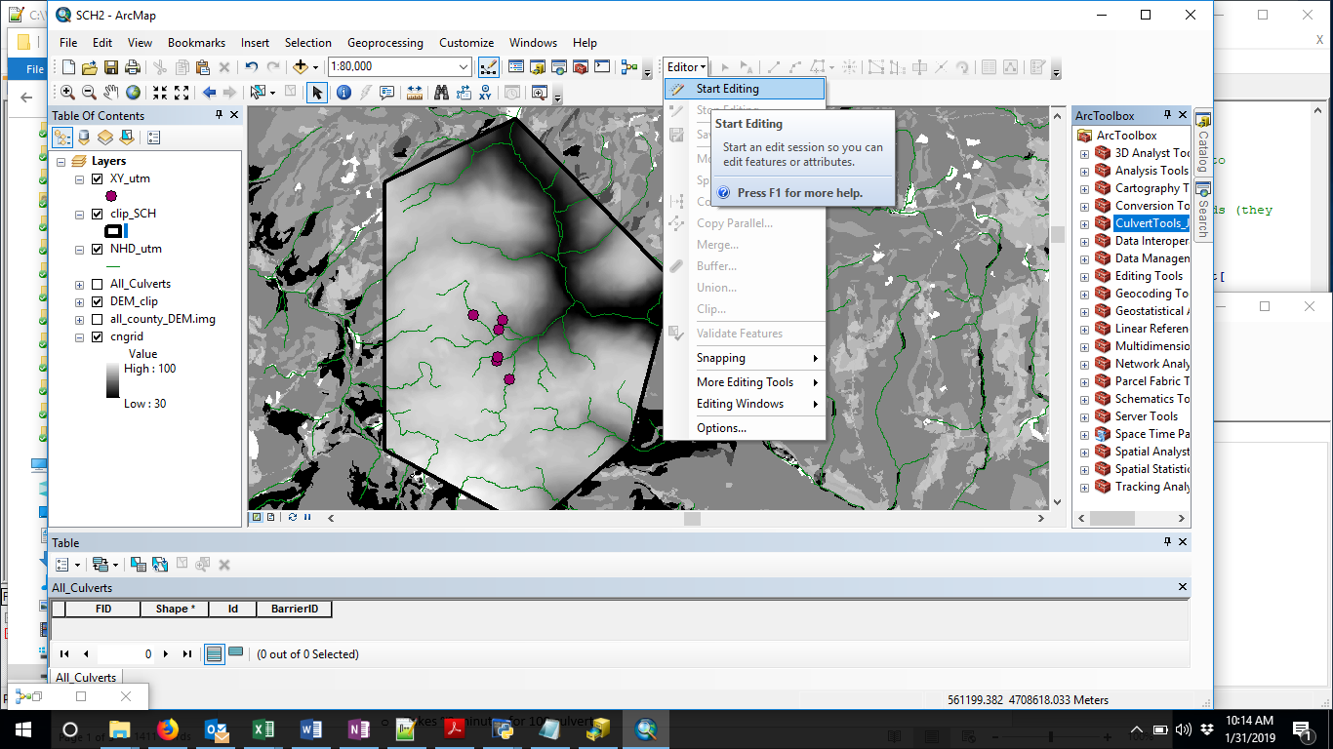

**Figure 1:** Create a polygon in your clip shapefile using the Editor Tool. The green lines indicate streams from the NHD layer. As you can see, all the streams upstream of the XY_utm points are complete, and there are unconnected streams in all directions around the points indicating that your clip area is large enough to capture the full watersheds contributing to those points.

1. Run the ArcGIS portion of the Cornell Culvert Model

* Open ArcToolbox and right click to add a new Toolbox. Navigate to where the CulvertTools_V2.1 is located and load it into your map document.
* Right click to edit the 00_clip_files tool in the CulvertToolbox . Set all the blue ellipses to reference the relevant files and folders for your project (Figure 2). Make sure that all files are projected to UTM. This will create smaller files to speed up processing time. It will also resample the CN file so that the raster cells are the same size as the DEM, which will prevent errors in calculating curve number values for culvert watersheds.
* Output: **NHD_lines_clip.shp, DEM_clip,** and **CN_res –** these files will be used as input for the next tool

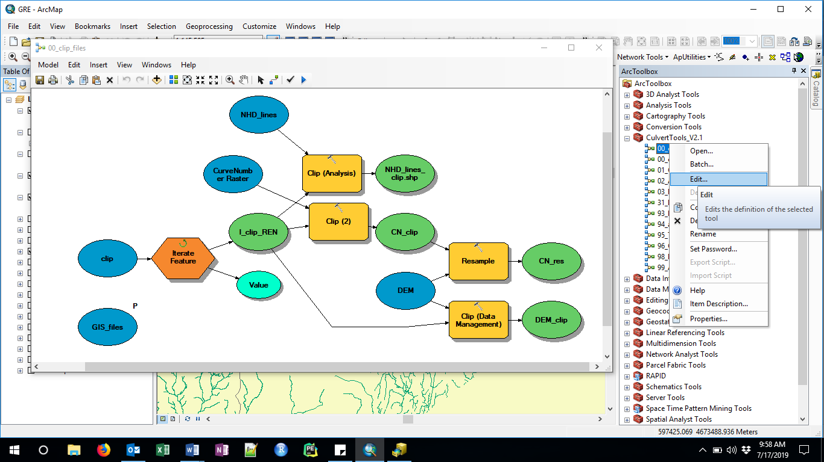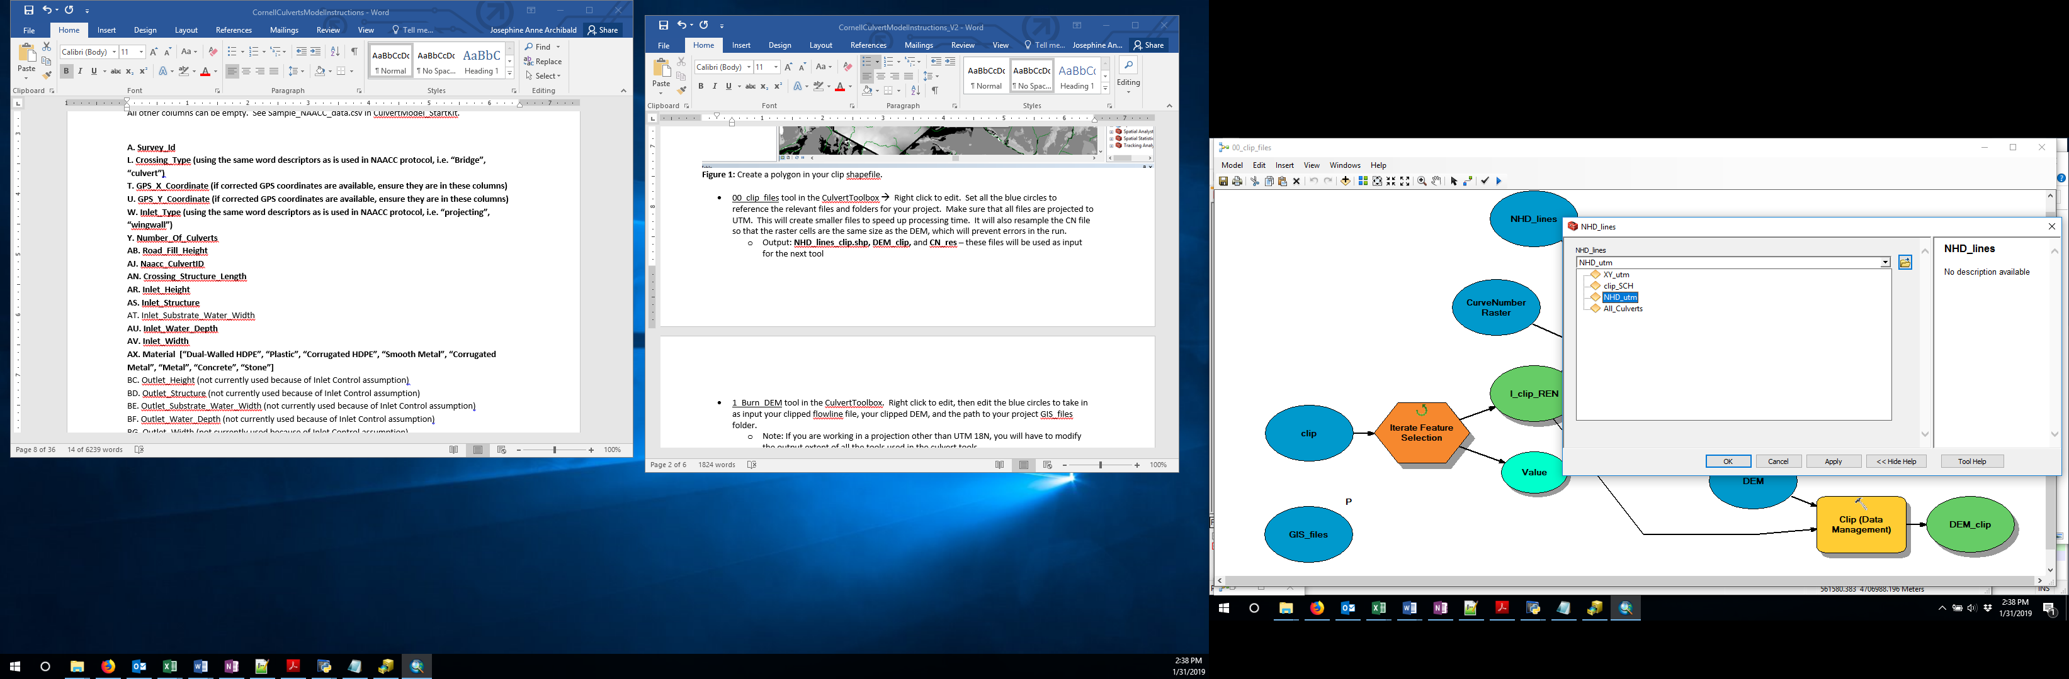

Figure 2: Editing the 00_clip_files model, and choosing the layer NHD_utm for the NHD_lines model parameter.

* Right click on the 01_Culvert_Watershed_Model to edit it. If you named your projected filed data points “XY_utm”, and created the clip files using the clip tool above, you only need to edit the GIS_files blue ellipse, to make it point to your project GIS_files folder location. If you created your input files differently, then make sure you click on all ellipses to make them point to the correct files. This tool calls on a number of sub-tools, and can take several hours depending on the size of your clipped DEM and the number of culverts. If you run into errors, you can run each of the sub-tools separately, making sure to edit the blue ellipses of each tool for all your files and folders. The major functions of this tool are outlined below.
  1. 98_Create_WS: This tool creates a watershed for each culvert point location in your XY_utm shapefile. Inputs are DEM_clip and NHD_lines_clip. First it will generate the intermediate files needed to delineate all your watersheds, including a DEM file with the streams burned into it (dem_burn), flow direction (fdir), flow accumulation (facc), and flow length rasters (flen), all saved to your DEMs folder. Then it creates a watershed for each stream crossing, saved in the WS_poly folder, and finally it will append the All_Culverts shapefile with all these watersheds. The sub-tools called are:
     1. 93_Model_WS_delin
     2. 94_append WS (You can start with this tool if you already have shapefiles of your watersheds saved in the WS_poly folder)
  2. 99_Add_fields: This adds Area, Tc (Time of Concentration), and CN fields to the All_Culvert Shapefile, and calculates values for each. The tools it calls on are:
     1. 95_Tc_calc
     2. 96_CN_calc
  3. Note – the intermediate models can be run independently, check each blue ellipse in each model, make sure the reference calls on your project files and folders. * In general, the **GIS_files** ellipse always needs to be specified, but many of the other blue ellipses will call on layer files whose relative file paths are dependent on your GIS_files folder, or are layers that are already open in the project, so you will not have to change them
* Once the run has completed, do a visual inspection of the All_Culverts shapefile, to make sure the culvert watersheds have not been cut off by the clip outline. You can take a look at the other files in the DEMs folder – in particular, facc.tif is the flow accumulation file, and should have 8 categories (e.g. see figure 3). See Appendix 3 for how to re-run portions of the model, if you have errors or if you have intermediate files (for example watershed shapefiles from other sources that you want to incorporate into the model).

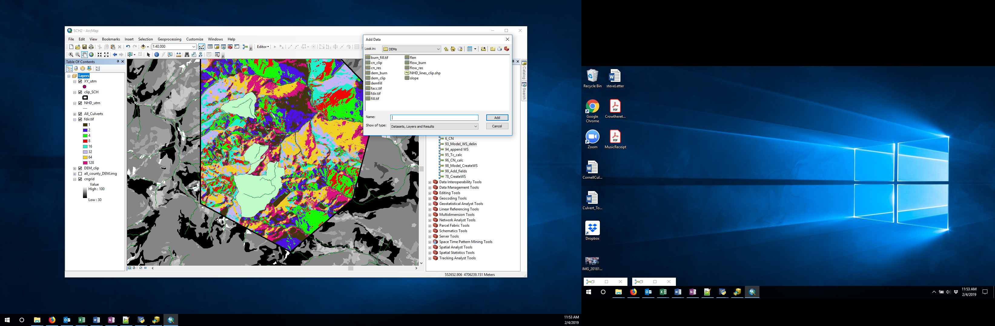

**Figure 3**. After the model has run, the All_Culverts file will have watershed shapes associated with each culvert. You can look at intermediate files created to generate this output in the GIS_files/DEMs folder (see Appendix 3 for details)

* [OPTIONAL] Add Precip and Region values to each watershed
  1. *00_clipP*: If you have downloaded NOAA precipitation rasters (corresponding to each of the following return intervals: 1,2,5,10,25,50,100,200,500), load all these raster files to ArcMap, and run 00_clipP. This tool assumes that you have kept the exact name of the rasters from NOAA for each return interval. The 1-year return interval has a slightly different naming convention – it should be “ne1yr24ha.asc”, the rest of the return interval rasters are assumed to have the following naming convention: “ne2yr24ha_ams.asc” (in this case, for the 2-year 24-hour rain event). To run this tool, you will only need to change the **GIS_files** ellipse (bottom left of the tool), and possibly the **DEM** ellipse (make it point to your DEM_clip file)
  2. *02_Add_Precip*: This file will now clip each precipitation raster to each watershed, and calculate the mean precipitation for each return period in each watershed. Make sure to change the GIS_files ellipse (circled in red, below)

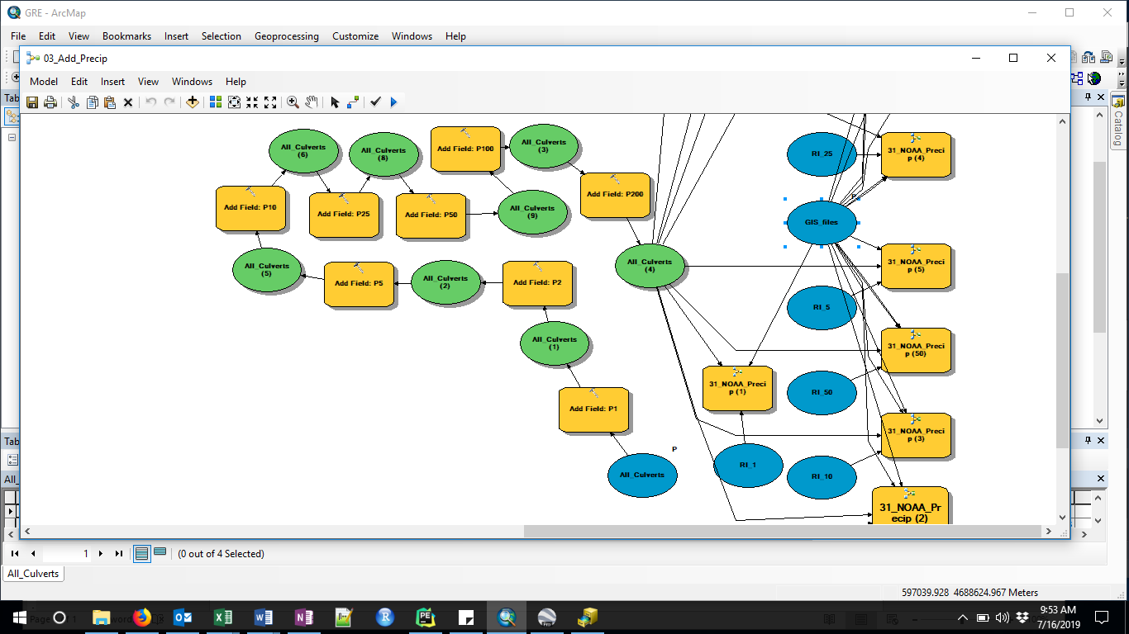

* 1. *03_Region*: Hydrologists at the NY State USGS (Lumia, 2006) have created equations to estimate streamflow based on watershed area for each of 6 regions in the state. If you have the shapefile called ff_regions from this analysis, you can use this to determine the region of each of your watersheds. Another option is to look at the region map in **Figure 4** and simply add a column to your All_Culverts output file, assigning all your watersheds to the region that seems to encompass your region (some counties are in two regions, so you might need to choose the region that has *most* of your culverts –don’t worry, this will not impact predictions returned, it simply allows a point of comparison for each culvert).
     + *Note:* If you are not using NOAA precip values, you cannot use this tool, instead you should respond to the prompt in the Culvert_Eval python script run with the region number that best encompasses your crossing watersheds. The way the model is structured currently, it does not allow you to specify different regions for each watershed if you are using an average precip value for all your culvert watersheds.



**Figure 4**. The six NY State StreamStats Regions (Lumia 2006).

* Right click on the **All_Culverts** (OR **All_Culverts_Full** if you used NOAA Precip and ran Precip tools) , and take a look at the attribute table. Click on the icon in the top-left of the table, and select “Export”. Save your file within your project folder, calling it **“All_Culverts.csv”,** after choosing ‘Text file’ in the drop-down menu for file type (Figure 5). It is important you use this exact file name, so that the python scripts can recognize it.

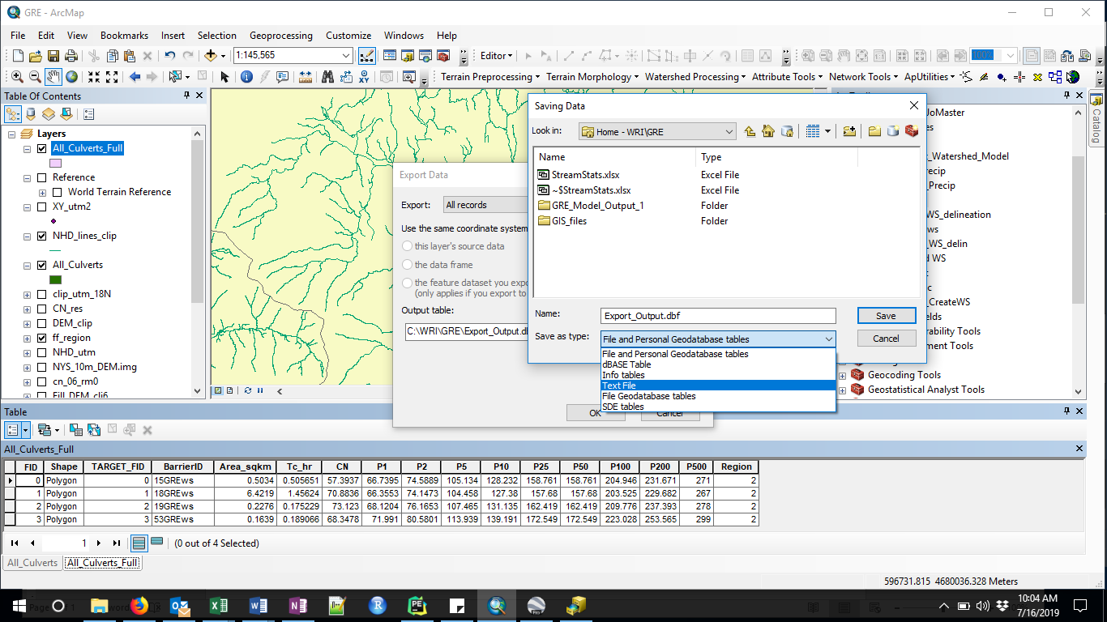

**Figure 5:** Saving the All_Culverts attribute table as a csv file – change the highlighted output name in the figure above to “All_Culverts.csv” after selecting Text File as the file type.

1. 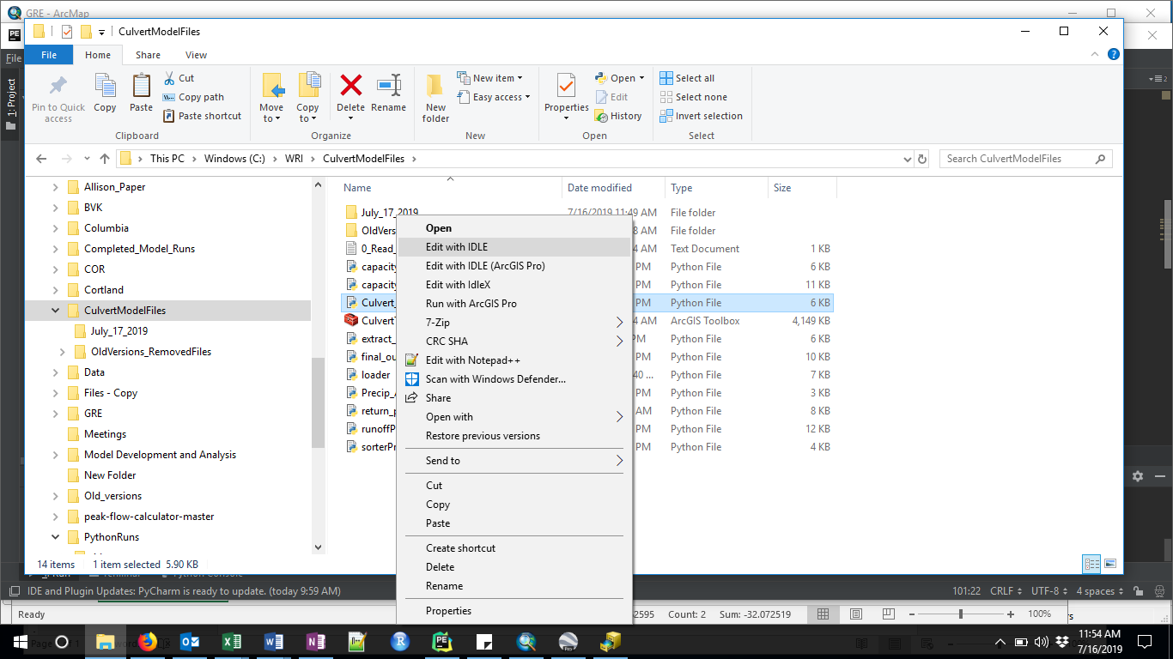Use the python script to compute the peak discharge, capacity and max return periods passed for each stream crossing

* Right click on the Culverts_Eval.py file in the “CulvertModelFiles” folder
  + 1. Select “Edit with IDLE”
    2. Once the script is open, hit F5 (This will open the python shell)
    3. This script will read in the output from the ArcModel, and needs the input file names to follow the naming convention described (e.g. if ALB is your project):
       - ALB/All_Culverts.csv (Arc culvert run export file)
       - ALB/ALB_precip.csv (if you did not use NOAA precip, and your All_Culverts file does not have precip and region columns
       - ALB/ALB_field_data.csv

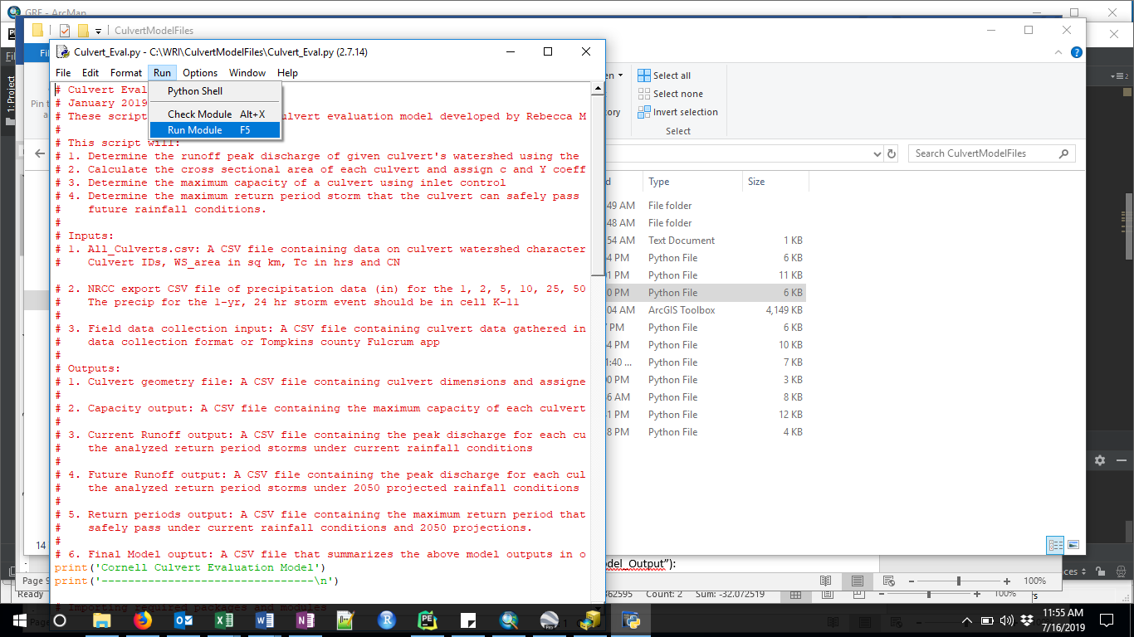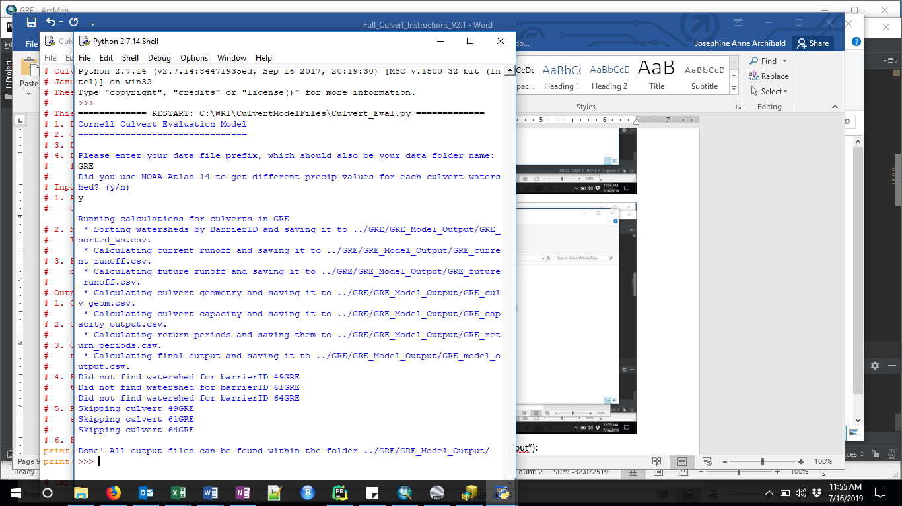

Script Outputs (in a new folder in your project folder, called “_Model_Output”):

1. culv_geometry: a csv file containing the areas of each culvert and assigned coefficients used in the capacity calculations
2. capacity_output: a CSV file containing the maximum capacity of each culvert before the headwater overtops the road surface
3. current_runoff: a CSV file containing the calculated runoff of each culvert watershed under the 1, 2, 5, 10, 25, 50, 100, 200 and 500 year storm events with current precipitation data
4. future_runoff: a CSV file containing the calculated runoff of each culvert watershed under the 1, 2, 5, 10, 25, 50, 100, 200 and 500 year storm events with projected 2050 precipitation data
5. return_periods: a CSV file containing the maximum return period storm that each culvert can safely pass for the current and projected 2050 precipitation data.
6. model_output: a CSV file containing a summary of the above 5 outputs. The file contains the maximum return period that each culvert can safely pass, the capacity of each culvert and information about culvert geometry. This file can be viewed as the final output of this model.
7. StreamStatsAreaBasedQ_CMS: This CSV file contains the predicted flow for a number of return periods based on the USGS-derived Area-based equations (in cubic meters per second, cms) (Lumia et al, 2006). This can be useful point of comparison for model output. However, because this StreamStats estimation uses only the area of the watershed to estimate flow, it does not take into account watershed characteristics or spatial or temporal precipitation variability. Columns C-D report the ratio of the present-day Culvert Model flow estimate to the StreamStats Area-based flow estimation .

**Reference**

Lumia, Richard, Freehafer, D.A., and Smith, M.J., 2006, Magnitude and frequency of floods in New York: U.S. Geological Survey Scientific Investigations Report 2006–5112, 152 p.

# Appendix 1: File structure for the Cornell Culvert Model V.2.1

**Figure A.1.** File structure for the Cornell Model run. Blue rectangles represent files and folders from the Cornell Culvert Model (Dark blue – ArcGIS toolbox; blue – Culvert model folders; light blue – culvert model files). Orange rectangles represent user-created folders and files, and green rectangles represent model output files and folders. Folder names have white text, file names have black text. The user created data folder must have the same name as the user-created data files name prefix, and be in the same directory as the CulvertModelFiles folder.

The schematic shows multiple data folders that the user might have – each would have the file structure indicated for Data Folder 1. Dark outlined folders (CulvertModelFiles and GIS_files) are copied from the CulvertModel GitHub account.

# Appendix 2: Required column numbers or names for the extract_NAACC.py program

* If you respond ‘n’ to the prompt, it does not matter what order your data columns take, but they must have the following **exact** names:
  + 'Survey_Id','Naacc_Culvert_Id','GPS_Y_Coordinate','GPS_X_Coordinate','Road','Material','Inlet_Type', 'Inlet_Structure_Type', 'Inlet_Width', 'Inlet_Height', 'Road_Fill_Height', 'Slope_Percent', 'Crossing_Structure_Length' ,'Outlet_Structure_Type', 'Outlet_Width', 'Outlet_Height', 'Crossing_Type' ,'Crossing_Comment', 'Number_Of_Culverts'
* If you respond “y” to the prompt, you must have these exact columns in your csv spreadsheet, but the names themselves don’t matter.

**A**. Survey_Id

**L**. Crossing_Type (using the same word descriptors as is used in NAACC protocol, i.e. “Bridge”, “culvert”)

**T.** GPS_X_Coordinate (if corrected GPS coordinates are available, ensure they are in these columns)

**U.** GPS_Y_Coordinate

**W.** Inlet_Type (using the same wording as NAACC protocol, i.e. “projecting”, “wingwall”)

**Y.** Number_Of_Culverts

**AB.** Road_Fill_Height AJ. Naacc_Culvert_Id

**AN.** Crossing_Structure_Length

**AR.** Inlet_Height

**AS.** Inlet_Structure

**AU**. Inlet_Water_Depth

**AV.** Inlet_Width

**AX**. Material [“Dual-Walled HDPE”, “Plastic”, “Corrugated HDPE”, “Smooth Metal”, “Corrugated Metal”, “Metal”, “Concrete”, “Stone”]

**BJ.** Slope_Percent

# Appendix 3: Intermediate files created by the Culvert Toolbox

* GIS_files/DEMs (all files clipped to the size of the clip shapefile)
  + burn_fill: The original DEM with streams burned and pits filled. This is the file used to determine flow accumulation, flow direction, and ultimately the watershed boundaries.
  + cn_clip: The original CN file, clipped to the extend specified by the user
  + cn_res: The resampled clipped CN file, resampled to the DEM raster size
  + demfill: Filled DEM (without burned streams)
  + facc: Flow accumulation raster
  + fdir: Flow direction raster – created using D8, meaning flow can come to any particular cell from any of the 8 raster cells around it. This file should have 8 distinct values (1,2 4,8,16,32,64,128)
  + flen: Flow length raster – used to calculate Time of Concentration (Tc) for each watershed
  + flow_burn: raster created from the NHD lines used to burn in streams to the DEM. Streams are represented by 1, all other areas are 0
  + flow_ras: Raster version of the NHD lines file – used to create the flow_burn file
  + slope: A raster of the slope values (in % rise), created from the filled DEM. Used in model versions before V2.1 to calculate the Time of Concentration

# Appendix 4: Intermediate tools in the Culvert Toolbox in Arc

If the full watershed model does not work, you can run each model component separately to see where the error occurs. Make sure you have run the 00_clip_files tool, and that you have a new, empty All_Culverts shapefile saved in your project’s GIS_files folder. Also, delete all files previously created in the GIS_files/WS_Poly folder (or save the folder under a new name, and create a new, empty folder called WS_Poly). Don’t worry about deleting files in the DEMs folder – these will be rewritten.

* 1_Culvert_Watershed_Model: Check to make sure that the necessary intermediate files were created before the tool failed – look inside your DEM folder to make sure you have DEM_burn, fdir, facc, CN_res files. If so, you can use t
* 93_Model_WS_delin: Delineate watersheds for each culvert
  + Right-click to Edit tool
  + Edit the four blue ellipses with your files and folders. This step takes the longest
* 94_append_WS
  + Check attribute table of the All_Culvert shapefile is empty
  + Edit tool to make the three blue ellipses point to your files/folders
  + Run 🡪 all watersheds into one shapefile
* 99_Add_fields: In this final step, you will add additional fields to the All_Culvert shapefile attribute table, and calculate the values for each watershed. You can do this in one step by editing the 99_Add_fields tool to reference your files which will complete the Arc portion of the model, or if you want to go slowly to error check, you can break it down further:
  + Add empty columns to the All_Culverts file for“Area_sqkm” (type=float), Tc_hr (float), CN (float)
    - Right click on the heading of the Area_sqkm, select “Calculate Geometry” and hit “yes” when the dialogue box pops up. Change units to square kilometers
  + Calculate Tc for each watershed
    - Edit the 95_Tc tool and change the blue circles for your files and paths. Use the slope raster that was created with the BurnDEM tool
  + Calculate the weighted CN for each culvert watershed by editing the Blue ellipses for your files in the 96_CN tool
* Once completed, export the attribute table from the All_Culverts file, or add NOAA Precip, below
  + *00_clipP*: If you have downloaded NOAA precipitation rasters (corresponding to each of the following return intervals: 1,2,5,10,25,50,100,200,500), load all these raster files to ArcMap, and run 00_clipP. This tool assumes that you have kept the exact name of the rasters from NOAA for each return interval. The 1-year return interval has a slightly different naming convention – it should be “ne1yr24ha.asc”, the rest of the return interval rasters are assumed to have the following naming convention: “ne2yr24ha_ams.asc” (in this case, for the 2-year 24-hour rain event). To run this tool, you will only need to change the **GIS_files** ellipse (bottom left of the tool), and possibly the **DEM** ellipse (make it point to your DEM_clip file)
  + *02_Add_Precip*: This file will now clip each precipitation raster to each watershed, and calculate the mean precipitation for each return period in each watershed. Make sure to change the GIS_files ellipse (circled in red, below)
  + *03_Region*: Hydrologists at the NY State USGS (Lumia, 2006) have created equations to estimate streamflow based on watershed area for each of 6 regions in the state. If you have the shapefile called ff_regions from this analysis, you can use this to determine the region of each of your watersheds. Another option is to look at the region map in **Figure 4** and simply add a column to your All_Culverts output file, assigning all your watersheds to the region that seems to encompass your region (some counties are in two regions, so you might need to choose the region that has *most* of your culverts –don’t worry, this will not impact predictions returned, it simply allows a point of comparison for each culvert).
    - *Note:* If you are not using NOAA precip values, you cannot use this tool, instead you should respond to the prompt in the Culvert_Eval python script run with the region number that best encompasses your crossing watersheds. The way the model is structured currently, it does not allow you to specify different regions for each watershed if you are using an average precip value for all your culvert watersheds.

# Appendix 5: Fixing Watershed errors in the Culvert Tool

Often, the Culvert Tool will incorrectly characterize a watershed due to the culvert location not matching up to the NHD streams. This usually results in a very small watershed being delineated. See example below – the red polygon is the watershed that the culvert tool delineated due to the misplaced culvert location. When we look at that culvert’s data point overlayed on a basemap, we can see that the point does not intersect with the road in its description. (See example image below)

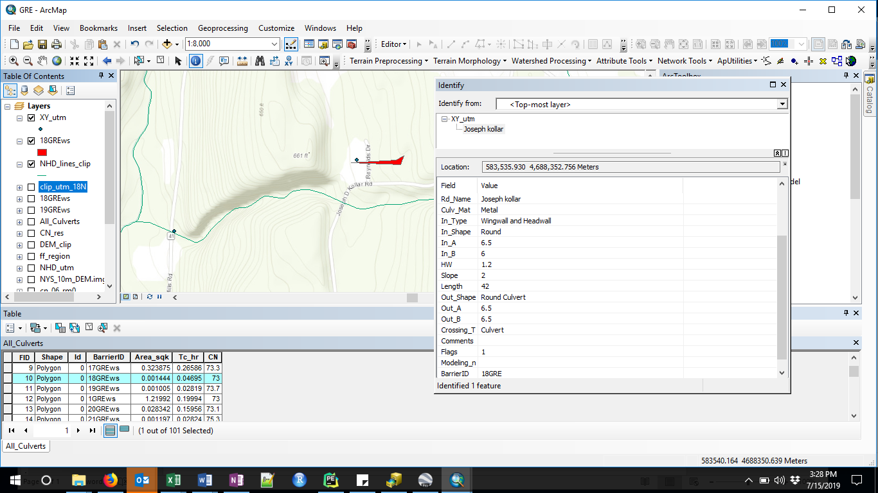

There are two relatively simply options for dealing with these types of errors.

1. If there is a clear streamline showing up on the NHD layer or basemap, you can edit the point shapefile and move that point location over to where the stream meets the road. (Remember to save and stop editing once you’ve moved all your points). Then re-run the culvert model with the edited XY_utm file. (To rerun simply your edited points, save only the points you moved in a new pointfile, called XY_utm_edit1). Then rename your existing All_Culverts_Shapefile and WS_poly folders in ArcCatalog, and recopy these files from the template GIS_folder taken from GitHub. **You must start with an empty All_Culverts shapefile for each new model run.** You will want to export your edited All_Culverts attribute table into a temporary csv file, and transfer the edited watershed information into your All_Culverts csv file.

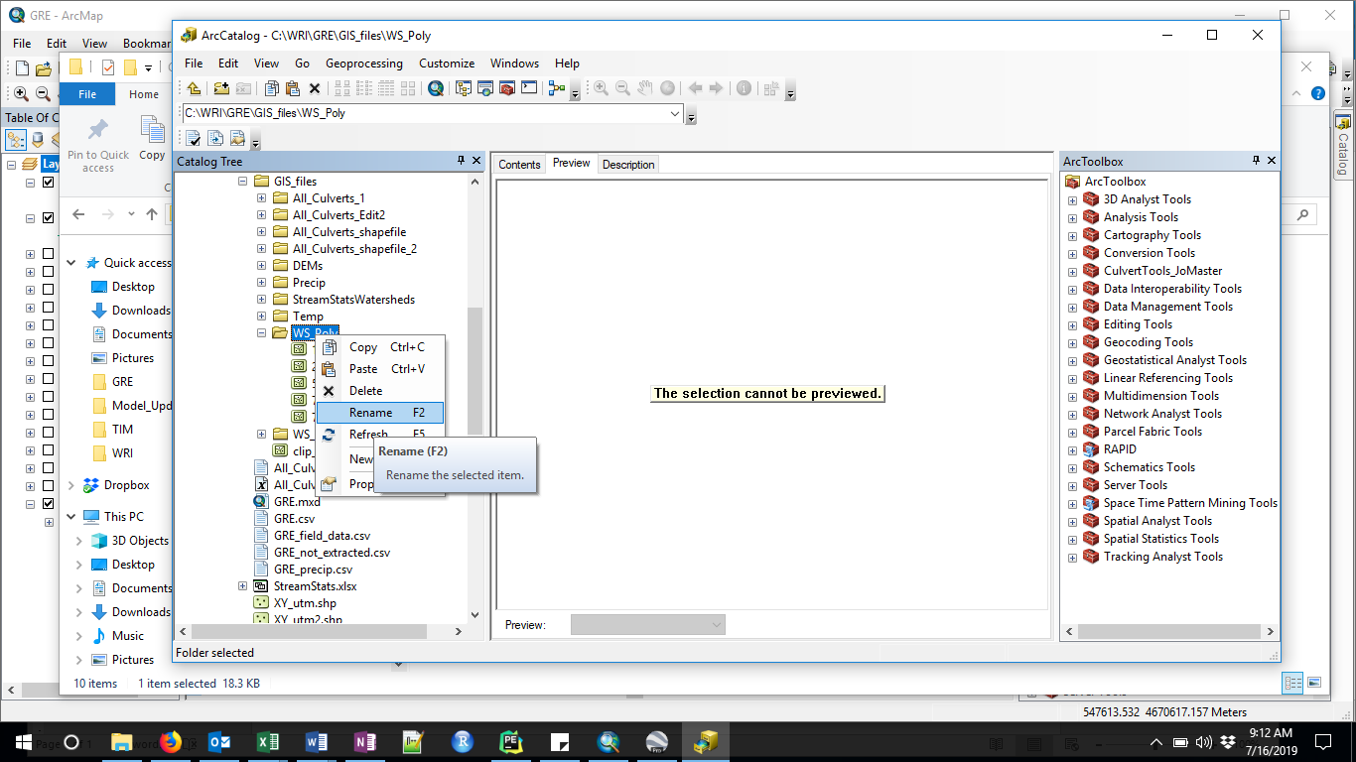

1. If you have watershed shapefiles from another source, for example, using the StreamStats application, save the watersheds to an empty WS_Poly folder in your GIS_files folder. Then run the 94_append_WS model, by right clicking, and editing the GIS_files blue ellipse so that it points to your GIS_files folder. Before running this, make sure you have an empty All_Culverts shapefile saved in your All_Culverts_shapefile folder. You should rename your previous All_Culverts and WS_Poly folders, or move them to a new folder called “Old_files”.

